User manual Enhanced Timesat envelop filter

Purpose
Reduce noise in time series data such as NDVI using a modified adaptive Savitzky-Golay filter, and forcing an upper envelope. It is a modification of the filter in TIMESAT 2.3.

Installation
Install the .sav files in the save_add folder (see also ENVI .sav files: Installation and configuration.
nrs_Utils.sav Library with utility routines
timesat_gui.sav The actual software

Usage
Timesat_GUI | Start the user interface of the timesat filter.
To start the envelop filter click the menu NRS | Timesat (NRS)
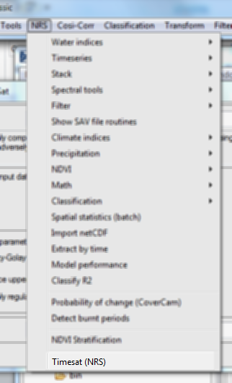
The following dialog pops up:
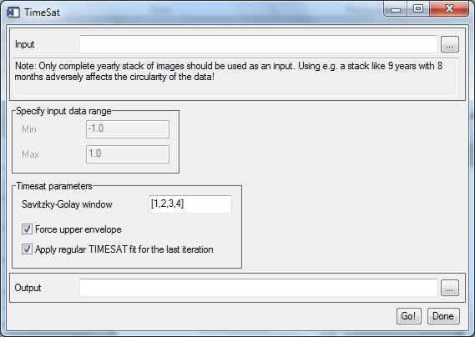
Input | The time series to filter
Specify input data range  Min  Max | The filter uses byte values internally. When floating point values are supplied, optionally the software will transform into the full byte range. After the filter the values are then scaled back to the original range.  Optional range adjustment, minimum value in input to consider  Optional range adjustment, maximum value in input to consider
Savitzky-Golay window | The filter iterates using different filter window sizes; this aids in filtering without losing too much detail. Usually the window sizes are in increasing order. Default is [1,2,3,4]. Note that the filter size indicates the number of samples at either side of the sample to consider, so the actual filter width is 2 x <window size> + 1 (it includes the value under investigation as well).
Force upper envelope | If enabled the filter will use the original value in favor of the fitted value if the fitted value is lower than the original value.
Apply regular TIMESAT fit for the last iteration | If enabled the filter will force the upper envelope for all filter window sizes except for the last. If disabled the envelope will also be forced to the upper envelope for the last windows size
Output | The output of the filter
The output format is plain ENVI format (BIL organization).

References:
Beltran Abounza, J.M. (2009) Method development to prepare from hyper - temporal images remote sensing RS - based change maps. Enschede, ITC, 2009. 53 p. (full text)
Original TIMESAT software: http://www.nateko.lu.se/timesat/timesat.asp

